Chapter 7, Problem 57.

Find i₁(t) and i₂(t) for t > 0 in the circuit of Fig. 7.123.

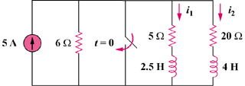

Figure 7.123
For Prob. 7.57.

